Canadian Tax Checklist
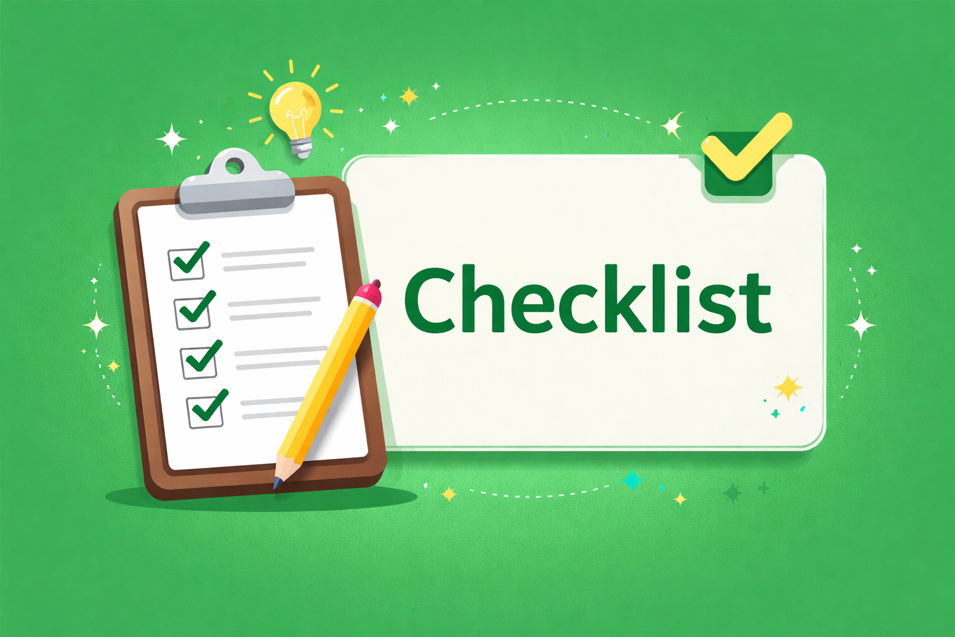

We’re here to help you claim all the tax credits and deductions available to you.

Before you begin preparing your return, gather all the necessary receipts and records of your income.

Here’s a handy checklist: (Use this convenient checklist to stay organized)

Slips
- T4 Slips (For Employment Income)
- Empployment Insurance benefits (T4A or T4E)
- Repayments of COVID-19 benefits
- Interest, dividends, mutual funds (T3, T5, T5008)
- T2202 Tuition and Enrollment Certificate
- Old Age Security and CPP benefits (T4A-OAS, T4AP)
- Other pensions and annuities (T4A)
- Social assistance payments (T5007)
- Workers’ compensation benefits (T5007)
- Advance Canada Workers Benefit (CWB) payments (RC210)
- All other information slips
- T4FHSA First Home Savings Account Statement

Receips.
- RRSP contribution receipts
- Support for a child, spouse or common-law partner
- Professional or union dues
- Tool expenses
(Tradespersons & apprentice mechanics)
- Office-in-home expenses
- Other employment expenses
- Teacher’s school supplies
- Medical expenses
- Home renovations (seniors and disabled)
- Multigenerational home renovation tax credit
- Charitable donations
- Political contributions
- Child care expenses
- Adoption expenses
- Moving expenses
- Interest paid on student loans
- Carrying charges and interest expenses
- Exams for professional certification
- Digital news subscription
- Labour Mobility Deduction for Tradespeople

Other documentation
- Notice of Assessment/Reassessment
- Canada Revenue Agency correspondence
- Sale of principal residence
- Sale or deemed sale of stocks, bonds or real estate
- Northern residents deductions receipts
- Rental income and expense receipts
- Business, farm or fishing income/expenses
- Automobile/Travel logbook and expenses
- Disability Tax Credit Certificate
- Declaration of Conditions of Employment (T2200)
- Volunteer Firefighters certification
- Search and Rescue volunteers certification
- Written certification for eligible educator school supplies
- Record of cryptocurrency transactions
- Register for CRA My Account.

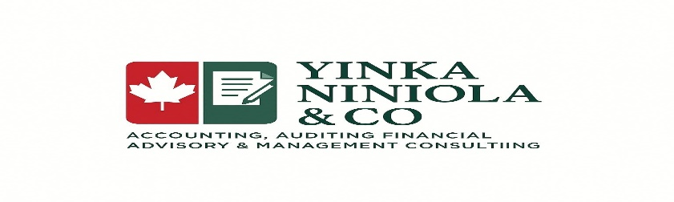
Email: info@yinkaniniola.com
Phone: 604-779-8384

